**CCM7 Plus: Unit 5 Study Guide- Proportional Relationships and Slope**

**Short Answer**

**Write a proportion and find the value of *x* in the diagram. Round to the nearest tenth if necessary.**

1. 

|  |
| --- |
|  |
| Not drawn to scale |

2. 



3. Charlene made the sketch below in order to find the height *x* of a pole. She positioned a mirror on the ground so that she could see the reflection of the top of the pole. Her height, her distance from the mirror, and her line of sight to the mirror determine the smaller triangle. The pole’s height, its distance from the mirror, and the distance from the top of the pole to the mirror form a larger similar triangle. Find the height of the pole to the nearest tenth.



4. Jimmy used a scale factor of 1/2 to reduce the following rectangle. What is the area of the new rectangle?.



5. A map shows the distance between the corner of Cactus Road and 1st Street and the corner of 1st Street and Merle Road as 3 inches. If the scale is 1 in. : 3.7 mi, what is the actual distance?

6. The triangles *ABC* and *XYZ* similar. What is the scale factor used to enlarge triangle XYZ to triangle ABC?



7. The front of Jane’s house is similar in shape to the front of Spot’s doghouse. If the base of the doghouse measures 5 feet and the height of its side measures 4 feet, what is the length of the base of Jane’s house, in feet, if the height of its side is 32 feet? (Round to the nearest tenth if necessary.)



8. Gretchen is using an overhead projector to enlarge a drawing so she can make a poster. The original drawing measures 60 mm wide by 80 mm high. She moves the projector so that the width of the projected image is 300 mm. If the original drawing and the projected image are similar figures, what will be the height of the projected image?

9. An engineer is drawing plans for a new water tower. The tower is 56 feet tall and the tank is circular with a diameter of 22 feet.

**a.** The engineer builds a model of the tower with a scale of 1 inch : 4 feet. What are the dimensions of the model?

**b.** Suppose the engineer decides to build a second model such that the height of model is 12 inches. What is the scale for the model?

10. Write an equation for the line.



11. Write an equation for a line with a slope of  and a *y*-intercept of 3.

12. Write an equation for a line with a slope of 0 and a *y*-intercept of 1.

**Graph the linear equation.**

13. *y* = 4*x* + 2



14. *y* = *x* + 4



15. **Find the slope of the line.**



16. **Find the slope of the line.**



17. **Find the slope of the line.**



**Identify the slope and *y*-intercept of the graph of the equation. Then graph the equation.**

18. 



**Find the slope of the line. Describe how one variable changes in relation to the other.**

19. 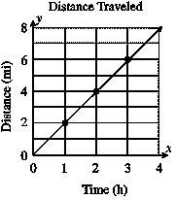

20. Write an equation for the graph.



22. David does landscaping for private homes and businesses. He charges $40 to travel to the site and then $40 per hour for his services. The equation *y* = 40 + 40*x* models the charge for his services *y* for any number of hours *x*.

**a.** Graph the equation.



**b.** What is the slope of the line? What does the slope represent?

**c.** What is the *y*-intercept of the line? What does the *y*-intercept represent?

**d.** Julia paid David $360 for his services. How many hours did David work? Explain how you got your answer.

23. Use the graph to answer the following questions.

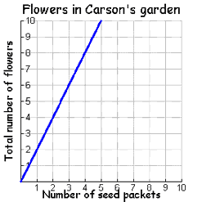

a. Does the graph represent a proportional relationship? How do you know?

b. What is the constant of proportionality?

c. What ordered pair on the graph makes the constant of proportionality easy to determine?

d. What does the point (3, 6) represent in this graph?

e. What is an equation that would represent the relationship in the graph?

**CCM7 Plus: Unit 5 Study Guide- Proportional Relationships and Slope**

**Answer Section**

**SHORT ANSWER**

1. ; 10

2. ; 8.9

3. 22.0 ft

4. 30 

5. 11.1 mi

6. 3

7. 40 ft

8. 400 mm

9. **a.** To find the dimensions for the model, write and solve a proportion using the scale for each dimension.

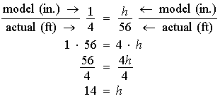

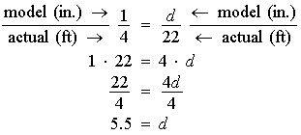

The model is 14 inches tall and 5.5 inches in diameter.

**b.** You need to find the scale of the model as a ratio of 1 inch to some number of feet. Write and solve a proportion using the height of the new model and the height of the actual tower.

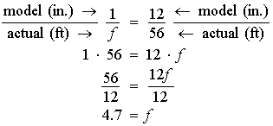 Write a proportion.

The scale is 1 inch : 4.7 feet.

10. *y* = *x*

11. *y* = *x*

12. 

13. 

14. 

15. undefined

16. 

17. 0

18. slope: –1; *y*-intercept: 0



19. 2; distance increases by 2 miles per hour

20. *y* = *x* – 6

21. *y* = *x* + 3

22. **a.** 

**b.** The slope is 40. This is the rate per hour.

**c.** The *y*-intercept is 40. That is the initial charge to come to the site.

**d.** 8 hours

23. a. yes, it is proportional because it is a straight line and it goes through the origin.

b. 2

c. (1, 2)

d. It represents that for 3 seed packets, Carson will get 6 flowers

e. f = 2s (where f = flowers and s = seed packets) or y = 2x