 | Problem 1 | Problem 2 | Gridded Response
Monday | Robert rode his bicycle for 4 hours and averaged 17 miles per hour. How far did he ride his bicycle? | A box contains 1 red ball, 3 green balls, and 8 blue balls. What best defines the probability associated with picking a red ball without looking?  A likely  B certain  C unlikely  D impossible | Problem 1  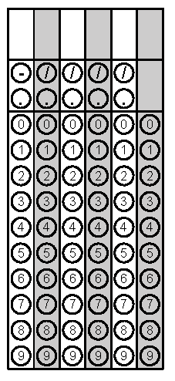
Tuesday | Katie dropped 5 nickels on the floor. What is the probability that all the nickels will land with heads facing up? | Solve for x. | Problem 2
Wednesday | A number cube with faces labeled 1 through 6 is rolled 200 times. About how many times would you expect to roll an even number? | A product used to have a price of $20.50. Its price was then increased by 2%. Additionally, a 7% tax is added when the product is purchased. What is the total cost, including tax, of purchasing the product? Round to the nearest cent. | Problem 2
Thursday | James has 16 ounces (oz.) of cookie dough. If he uses 0.56 oz. of cookie dough for each cookie, what is a reasonable estimate of how many cookies he can make? | Ranee creates a spinner with 12 equal sections. She colors 5 of the sections orange, 2 green, 3 blue, and 2 yellow. What is the probability that the arrow on the spinner will land on a blue section? | Problem 2
Friday | A bag contains 30 blue beads, 10 red beads, and 35 yellow beads. Julia pulls a bead out of the bag at random, puts it aside, and then pulls another bead out of the bag at random. What is the probability that Julia will pull two red beads out of the bag? | Two angles are supplementary. The measure of one angle is 4 times the measure of the other angle. What is the measure of the smaller angle? | Problem 1
Questions adapted from Score21 and SchoolNet

