 | Problem 1 | Problem 2 | Gridded Response
Monday | An image is graphed at coordinates A (5, 2), B (-5, 6), and C (-1, 2). If this image has been rotated 90 degrees counterclockwise, what were the original coordinates? | Charlotte earns $1,595 per month at her job. She will receive a 7% raise. How much more money will Charlotte earn each year after her raise? | Problem 2  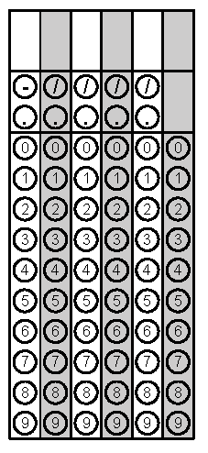
Tuesday | A pre-image is graphed at coordinates A (-5, 2), B (-5, 6), and C (-1, 2). If this image is reflected over the x-axis, what are the new coordinates? | A family made three trips to the grocery store in one month.  - On the first trip, they spent $100 on groceries.  - On the second trip, they spent 20% less than they did on the first trip.  - On the third trip, they spent ¾ as much as they did on the second trip.  What was the total amount of money the family spent on groceries for the month? | Problem 2
Wednesday | Given a line with coordinates A (-4, -3) and B (-9, -7) what would the new prime coordinates be after a reflection over the x-axis? | A right triangle has an angle that measures 35°. Which is the measure of another angle in the triangle? | Problem 2 - the largest angle
Thursday | In how many ways can you park a blue car, a red car, a green car, and a gray car? | A teacher bought a bag of candy with 240 pieces.  She gave 30% of the pieces to another teacher.  She put half of what was left in the bag into a jar on her desk.  She gave the 25 students in her class an equal amount of the remaining candy in the bag.  How many pieces of candy does the teacher have left in the bag? | Problem 1 – measurement of the longest side
Friday | Photo researchers review thumbnail, or reduced, photos to choose which ones to buy. One thumbnail photo is 2 inches wide by $1\frac{1}{3}$ inches wide. The actual photo is similar to the thumbnail, but its dimensions are increased by a factor of 3. What are the dimensions of the actual photo? | In triangle XYZ, side XY measures 6 inches, side YZ measures 8 inches, and side XZ measures 10 inches. List the angles of the triangle in order from largest angle to smallest angle. | Problem 1 – measurement of the longest side
All problems 2 taken from SchoolNet

