 | Problem 1 | Problem 2 | Gridded Response
Monday | 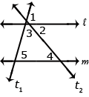  Find the measure of angle 5 if angle 1 measures 80 degrees and angle 2 measures 50 degrees. | 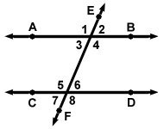  The measure of <5 is 5x + 1 and the measure of < 6 is  x – 1, find the value of x. | Problem 1  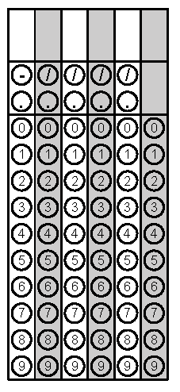
Tuesday | If Brandon was standing at the origin on a coordinate grid and moved 2 spaces left and 5 steps up, where would he be standing? | Find the measure of angle b.  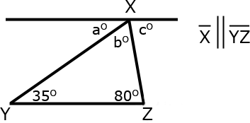 | Problem 2
Wednesday | An isosceles triangle has an angle that measures 100°. What is the measure of one of the other angles in the isosceles triangle? | Members of a marching band begin in a trapezoid formation that can be represented by trapezoid KLMN with vertices:  K (-2, 1) M (3, -3)  L (1, 1) N (-4, -3)  Then, they move 5 steps right and 4 steps down. Give the coordinates of point K' after the translation. | Problem 1
Thursday | Destiny graphed a pre-image in quadrant 3. If she rotates the pre-image 90 degrees clockwise, then 270 degrees counterclockwise, and then 180 degrees clockwise, in which quadrant will her image be located? | Two angles are supplementary. If one angle measures 72°, what is the measure of the other angle? | Problem 2
Friday | David has $100 to spend on clothes for school.  He has a coupon for $10 off when he spends at least $50.  He buys a pair of pants for $27.99, two t-shirts for $12.99 each, and a pair of shoes for $34.99.  The sales tax is 8% of the total after the coupon is applied.  How much money will David have left after his purchases? Round to the nearest cent. | A pre-image is graphed at coordinates A (-5, 2), B (-5, 6), and C (-1, 2). If this image is rotated 180 degrees, what are the new coordinates? | Problem 1
Wednesday question 1, Thursday question 2, and Friday question 1 taken from SchoolNet.

