 | Problem 1 | Problem 2 | Gridded Response
Monday | A rectangle has a length of 5x – 18 and a width of  11x – 7. If the perimeter is 110 inches, what are the length and width? | If points R (–3, 2), S (5, 2), T (5, –4), and U (–3, –4) are on the coordinate plane, what’s the area of the quadrilateral formed? | Problem 1 - the length  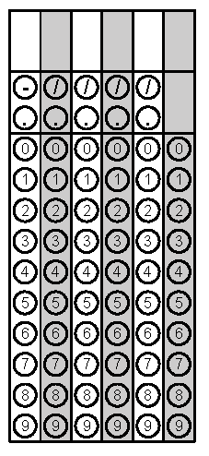
Tuesday | If a triangle has all equal sides and has a perimeter of 42cm, what is the length of each side? | A girl builds a rectangular prism out of wooden cubes. She uses 50 cubes that measure ½ inch on each edge. What is the volume, in cubic inches, of the rectangular prism she builds? | Problem 1
Wednesday | If a triangle has 2 equal side lengths, a third side length of 32 in. and has a perimeter of 94 in, what are the missing side lengths for the triangle? | An open-topped fish tank has a length of 30 inches, width of 10 ½ inches, and height of 12 inches. What is the volume of the water in the tank if the tank is ¾ filled? | Problem 2
Thursday | Draw a quadrilateral with one set of parallel sides and no right angles (taken from DPI’s unpacked document) | Two supplementary angles have the measurement of  4x + 8 and 2x – 14. What is the value of x? | Problem 2
Friday | Can a triangle have more than one obtuse angle? Explain your reasoning (taken from DPI’s unpacked document). | Two complementary angles have the measurement of 2x + 8 and 3x – 13. What is the value of x? | Problem 2
Problem 2 on Days 1-3 taken from SchoolNet

