 | Problem 1 | Problem 2 | Gridded Response
Monday | Jacques is going grocery shopping. He has two coupons to choose from. One coupon is 10% off the entire purchase while the other is $20 off. If his total is 189.90, which is the better coupon to use? | Simplify  $$3\left(1\frac{1}{2}x\right)+ \frac{3}{5}\left(5x-10\right)$$ | Problem 1  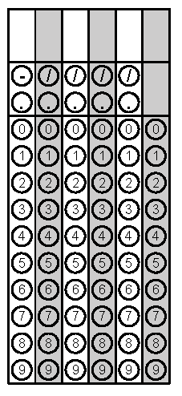
Tuesday | Bridget is playing indoor soccer on 3 different leagues. If she burns 413 calories per hour and she plays in four 1.5 hour games this week, how many calories does she burn off? | Bilk’s is having a 20% off sale on pajama pants. If the sale price is 12.50, what was the original price of the pajama pants? | Problem 2
Wednesday | Jeff is a real estate agent. He earns 3% commission on his sales. If he sells a house for $390,000, how much commission will he make? | Simplify  $$\frac{4}{9}x+12- \left(\frac{5}{6}x+78\right)$$ | Problem 1
Thursday | Victoria renovated a house for $71,000. If she paid $506,000 for the house, what percent of the original cost did she spend renovating the house? Round to the nearest hundredth. | How many meals can be made from 5 appetizers, 4 main dishes, and 4 desserts? | Problem 1
Friday | Marcia bought plane tickets for $345. If she sees the same ticket on sale for $405 a week later, what percent increase did the airline use? Round to the nearest hundredth. | George babysat for 5 hours and earned $62.50. He then babysat for 8.5 hours and earned $106.25. Is this a proportional relationship? If yes, what is the constant of proportionality? | Problem 1

