 | Problem 1 | Problem 2 | Gridded Response
Monday | Solve.  - b - 7 = 16  - 9c = 99  - $\frac{n}{5}$= 30  - a - 25 = 5 | A group of volunteers planted 24 trees in 8 hours.  a) At what unit rate were the trees being planted?  b) At that rate, how many hours would it take the volunteers to plant 120 trees? Show all the steps you used to find your answer. | Problem 1C  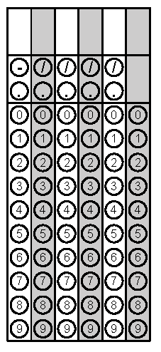
Tuesday | Given a square pool as shown in the picture, write four different expressions to find the total number of tiles in the border. Explain how each of the expressions relates to the diagram and demonstrate that the expressions are equivalent. Which expression is most useful? Explain.  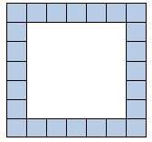 | Ms. Holmes decided to water her plants. She had 2$\frac{1}{2}$gallons of water. She gave each plant $\frac{1}{4}$gallon of water. How many plants did she water if she used all of her water? | Problem 2
Wednesday | Solve for n.  -2n + (-8) - 6n = 24 | The width of a rectangular park is 23.4 yards. What is the perimeter of the park if the length is 2.5 times larger than the width? | Problem 1
Thursday | Does x always have to be a positive number?  If x is a negative number, then what would -x equal?  x and -x are opposites with a sum of 0. What is their quotient? | 3 more than 6 times a number equals -15. What is the number? | Problem 2
Friday | - Abigail is 4 years younger than Breanna.  - Breanna is twice as old as Carlos.  - Carlos is x years old.  a) Write an expression for Abigail’s age in terms of x. Show or explain your work.  b) If Carlos is 9 years old, how old is Abigail? Express Abigail’s age in years. Show or explain your work. | At the local bank, 60% of the employees have 2 or more children. There are 240 employees that have fewer than 2 children. How many employees does the bank have? | Problem 2

