 | Problem 1 | Problem 2 | Gridded Response
Monday | Solve.  $$a) 3\frac{1}{3} × -9$$  b) $-1\frac{7}{9}÷-\frac{8}{9}$ | For every 6 cups of flour, 3 cups of sugar are needed to make cookies.  - What is the ratio of flour to sugar? Write your answer as a fraction.  - Using the same ratio, how many cups of sugar are needed for 3 cups of flour? | Problem 2B  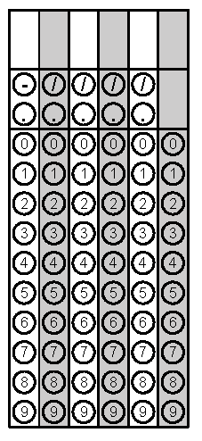
Tuesday | Jimmy has 11 cookies. He wants to share them with his three best friends. How many cookies will Jimmy and each of his friends get? | Solve:  a) 4 + (-9)  b) -3 + (-9)  c) -3 + 10 | Problem 1
Wednesday | A hiking trail is 6 $\frac{2}{3}$miles long. It has 4 exercise stations, spaced evenly along the trail. What is the distance between each exercise station? | The elevator in a mall goes 30 ft below ground level. What integer represents this depth in feet? | Problem 2
Thursday | A box of cereal contains 15$\frac{3}{5}$ ounces of cereal. If a bowl holds 2$\frac{2}{5}$ ounces of cereal, how many bowls of cereal are in one box? | What is the greatest common factor of 8 and 12?  What is the least common multiple of 8 and 12? | Problem 1
Friday | A one-half gallon carton of orange juice costs $1.89. A one-gallon carton of orange juice costs $2.99. How much money would you save if you bought a one-gallon carton instead of 2 one-half gallon cartons? | The mathematics club wants to divide the boys and girls into the greatest number of teams possible. Each team will have the same number of boys and the same number of girls. There are 84 boys and 72 girls. How many boys and girls will be on each team? | Problem 1

