 | Problem 1 | Problem 2 | Gridded Response
Monday | Round the following to the nearest tenth:  - 3.74  - 6.382  - 7.948 | Convert the following to improper fractions:  - 5$\frac{7}{24}$ =  - 2$\frac{5}{12}$ =  - 3$\frac{1}{6}$ = | Problem 2C  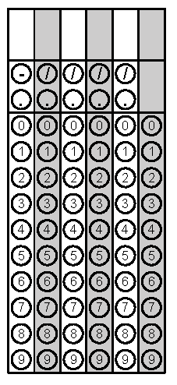
Tuesday | Our school just completed a fundraiser. We need to decide which homeroom had the highest sales because they will win a pizza party. The five eighth grade homeroom teachers reported their sales as a fraction or decimal of total school sales. Order these from greatest to least to decide the winner. (The winner is the homeroom with the greatest sales.)  Homerooms  Brown 3/8  Steele 0.12  Peterson 1/9  Mabry 0.15  Lawrence 1/4 | What is the additive inverse of 3? | Problem 2
Wednesday | Solve.  78 + (-96)  89 - (140) | Jim's cell phone bill is automatically deducting $32 from his bank account every month. How much will the deductions total for the year? | Problem 2
Thursday | James wants to buy a pair of pants that cost $49.50, a package of 6 pairs of socks for $14.99, a shirt for $56.84, and a tie for $42.73. If he has $180, how much change will he get from the cashier? | We want to buy some material for a costume for Halloween. If the fabric we want to buy costs $1.35 per yard and we need 3.25 yards, and we only have $5.00, do we have enough money to buy the fabric? | Problem 1
Friday | Mary makes $7.56 an hour working at the local fast food restaurant. What will her gross pay be for the week if she works 7.5 hours? If she wants to buy a stereo for $50.00. Does she owe money (negative) or have extra money (positive)? | Solve.  - ½ - ¾  - 2 $\frac{1}{3}$ + (-$\frac{3}{4}$) | Problem 2B

