 | Problem 1 | Problem 2 | Gridded Response
Monday | Subtract:  6 – (-4) | Find 30% of 62. | Problem 1  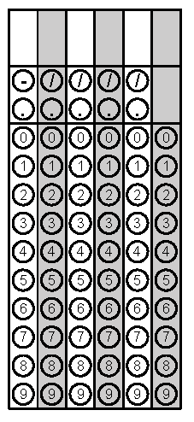
Tuesday | Find the LCM of 39 and 26. | If you borrow 2 dollars for lunch 3 days in a row, how much money do you owe? Write as an integer. | Problem 2
Wednesday | If you pay 5 dollars for lunch 3 days in a row and your mom gives you $10.50, how much money do you still need to pay for the lunches? | Solve  $\frac{11}{12}= \frac{x}{168}$ | Problem 1
Thursday | Solve.  4² + 48 ÷ (10 - 4) | - What is the opposite of 12?  - What is the opposite of the opposite of 12?  - What is the opposite of the opposite of the opposite of 12? | Problem 1
Friday | During a 5-day period, the stock market went down every day. At the end of the period, the stock market index had changed -20 points. What was the average change in the index per day?  A -2 points  B -4 points  C -5 points  D -15 points | Evaluate the following expression:  $$\left|9-5\right|—\left|- 6-(-8)\right|$$ | Problem 2

