Identifying Angles Notes Name ______________________

Vocabulary | Definition | Picture
Complementary Angles | Two angles whose sum is 90º
Supplementary Angles | Two angles whose sum is 180º
Vertical Angles | Two angles that are opposite each other when two lines cross. They share the same vertex.
Adjacent Angles | Two angles who share a vertex and one ray.

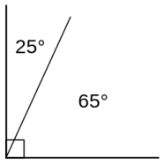  A | B | 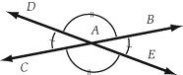  C | D
Match the diagrams above to the matching term below.
Complementary Angles
Supplementary Angles
Vertical Angles
Adjacent Angles
Pause the video and try these on your own!
Then press play and check your answers with a color pen

Name at least two of each type of angle(s). You may want to color or highlight each type.
Complementary Angles
Supplementary Angles
Vertical Angles
Adjacent Angles

