Spiral Review – EOG Review #2 Yes Calculator Name _________________
Due Monday, March 25th Show Work On Separate Paper
1. What factor could fill in the two empty blanks to create a proportional relationship?  A.  B. 1.5  C. 4  D. 6 | 2. The ladders shown below are standing against the wall at the same angle. How high up the wall does the longer ladder go? (All measurements are in feet.)  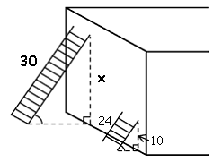  - 25 feet  - 12.5 feet  - 14 feet  - 11.25 feet
3. The table below shows the amount of money that Bonnie spent during her last trip to Target.  Target Purchases  Clothing $56  Groceries $82  School Supplies $16  To the nearest percent, what percent of the total did she spend on groceries?  - 10%  - 36%  - 53%  - 88% | 4. A 3-pound package of ground beef is $7.80. A ½-pound package is $1.28. What is the difference in the cost per pound between the larger and smaller packages of beef?  - The larger package costs $6.52 per pound more than the smaller package.  - The larger package costs $2.60 more per pound than the smaller package.  - The larger package costs $1.32 more per pound than the smaller package.  - The larger package costs $0.04 more per pound than the smaller package.
5. Lauren made 15 cups of lemonade by mixing lemon juice and sugar water. The ratio of lemon juice to sugar water is 2 : 3. How many cups of lemon juice are in the lemonade?  - 6 cups  - 9 cups  - 10 cups  - 22.5 cups | 6. Penelope is driving to college. She looks at a map to find out how far she has to drive. On the map, Penelope measures the distance to be 7.5 inches. If the map scale is 1.5 in. = 40 mi, how many miles does Penelope need to drive?  - 200 miles  - 210 miles  - 300 miles
7. Karla, an editor for “The Legacy” newspaper, edit $\frac{1}{5}$ of a page in 3 minutes. How long would it take Karla to edit 3 pages?  - 9 minutes  - 15 minutes  - 45 minutes  - 60 minutes | 8. On a map, the length of the road from town A to B is 12 inches. On this map, ¾ inch represents 8 miles. What is the actual distance from town A to B in miles?  - 128 miles  - 96 miles  - 72 miles  - 1.125 miles
9. Jennifer’s new bike costs $96. Her parents paid 40% of the cost and Jennifer paid the rest. How much did Jennifer pay?  - $38.40  - $57.60  - $130.00  - $134.40 | 10. Leann purchased a new computer for her birthday. She had to pay 7.5% sales tax on the computer. If she paid $63.75 in sales tax, how much did the computer cost?  - $4.78  - 68.53  - $850  - $900
11. Miller earns $70,000 per year and puts 7% of his earnings into a savings account. What is the total amount in Miller’s savings account after 1 year if the interest rate is 3%?  - $147  - $2,100  - $5,047  - $72,100 | 12. A writer earns 8% of total sales dollars as a commission. If 2,000 copies of his book are sold at $14.95 each, how much commission does he earn?  - $1.20  - $119.60  - $160  - $2,392
13. Yosef purchased a new sweater. The total price of the sweater, including the 8% sales tax, was $16.74. What was the retail cost of the sweater (before tax)?  - $15.40  - $15.50  - $18.08  - $16.66 | 14. The sweatshirt you purchased was on sale for $29.25, having been marked 35% off. What was the original price?  - $45  - $39.49  - $35.46  - $19.01
15. Cameron’s friend John is going to Italy. She wants John to bring her back a souvenir item but Italy uses the Euro as its own unit of currency. If Cameron gives his friend $50, about how many European Euros can John spend on the souvenir?  Conversion: 1 US Dollar = about .77 European Euro  - About $39  - About $49  - About $50  - About $65 | 16. Theo uses a cookie recipe that requires ½ cup flour to make 18 cookies. If Theo wants to make 4 dozen cookies, how much flour should Theo use?  - 1 cup  - $1\frac{1}{3}$ cups  - $2\frac{1}{4}$ cups  - $2\frac{2}{3}$ cups
17. The following table represents a proportional relationship between the number of bagels purchased and the cost. Which equation can be used to find the cost for 13 bagels?  Number of Bagels (b) Cost (c)  1 .75  2 1.50  3 2.25  4 3.00  - c = 1 - .75b  - c = .75b  - c = 13(.75b)  - b = .75c | 18. Fallon works at Baker’s Book company. If she earned a commission of $63.75 on her sales of $850, what was Fallon’s rate of commission?  - 7.5%  - 8%  - 10%  - 75%
19. What is the constant of proportionality and what does it mean? Pick the letter that best represents the answer.  A. The constant of proportionality is 1. This means one seed packet will produce four flowers.  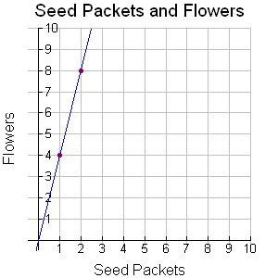  B. The constant of proportionality is 4. This means one seed packet will produce four flowers.  C. The constant of proportionality is 2. This means two seed packet will produce eight flowers.  D. The constant of proportionality is 8. This means two seed packet will produce eight flowers. | 20. Is the total number of flowers in the garden proportional to the number of seed packets used? Use the letter that best represents your answer on the final answer line.  A. It is NOT proportional because it is not linear and does not go through the origin.  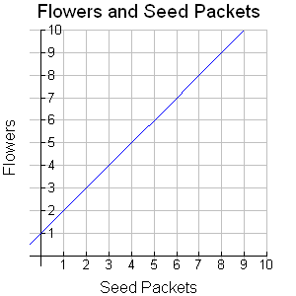  B. It is NOT proportional because although it is linear, it does not go through the origin.  C. It is proportional because it is linear and it goes through the origin.  D. It is proportional because it is linear and it does not matter if it goes through the origin.

