**Box-and-Whisker Plots NOTES Name _________________**

What makes up a box plot?

The box plot is placed either _________ or __________ a number line, ______ on the number line

What are those terms? #1-5 are called a “five number summary.”

#1: Median - The ___________ value when the data is ______________

#2: Lower/First Quartile (LQ) - The ___________ value of the ____________ half of the data

#3: Upper/Third Quartile (UQ) - The ___________ value of the ____________ half of the data

#4: Lower Extreme (LE) - The ___________ value

#5: Upper Extreme (UE) - The ___________ value

#6: Interquartile Range (IQR) - The ___________ between the _________ and ___________ quartiles.

#1Example: **24, 20, 18, 25, 22, 32, 30, 29, 35, 30, 28, 24, 38**

**1st** Put the data ________________ **2nd** Find the ____________________**3rd** Find the __________________

**4th** Find the ___________________ **5th** Find the _____________________**6th** Find the _________________

**Create** the box-and-whisker plot for this data on the top of the **next page**…

LE _______ LQ ________ Median________ UQ _________ UE__________

Make the box plot:

Interquartile Range: _______ - _______ = _______

From LE to LQ is _______% of the data From Median to UQ is _______% of the data

From LQ to Median is _______% of the data From UQ to UE is _______% of the data

Finding Information from a Box Plot

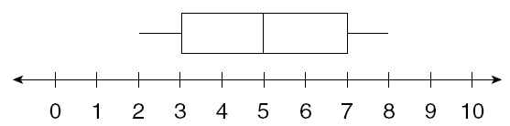

1. What is the median? _______ 2. What is the upper quartile? _______

3. How many people were surveyed? _______ 4. What is the IQR? ________

5. What is the range of the data? ______ 6. What is the mean? _________



1. What is the lower quartile? _______ 2. What is the upper quartile? _______

3. What is the range of the data? _______ 4. What is the IQR? ________

5. What percent of the data falls between 8 and 12? ______

6. What percent of the data is more than 15? ______