Using a Protractor Notes Name ______________________

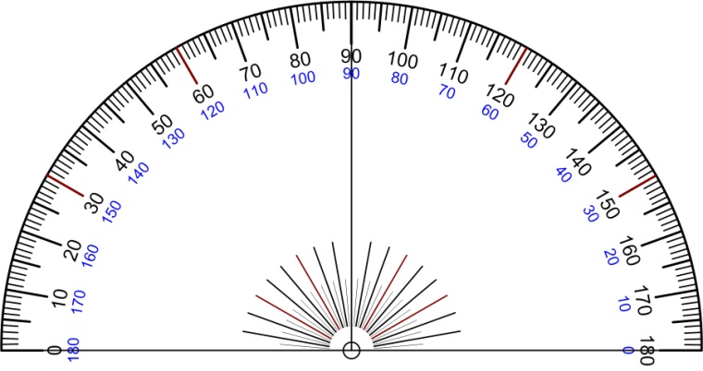 | 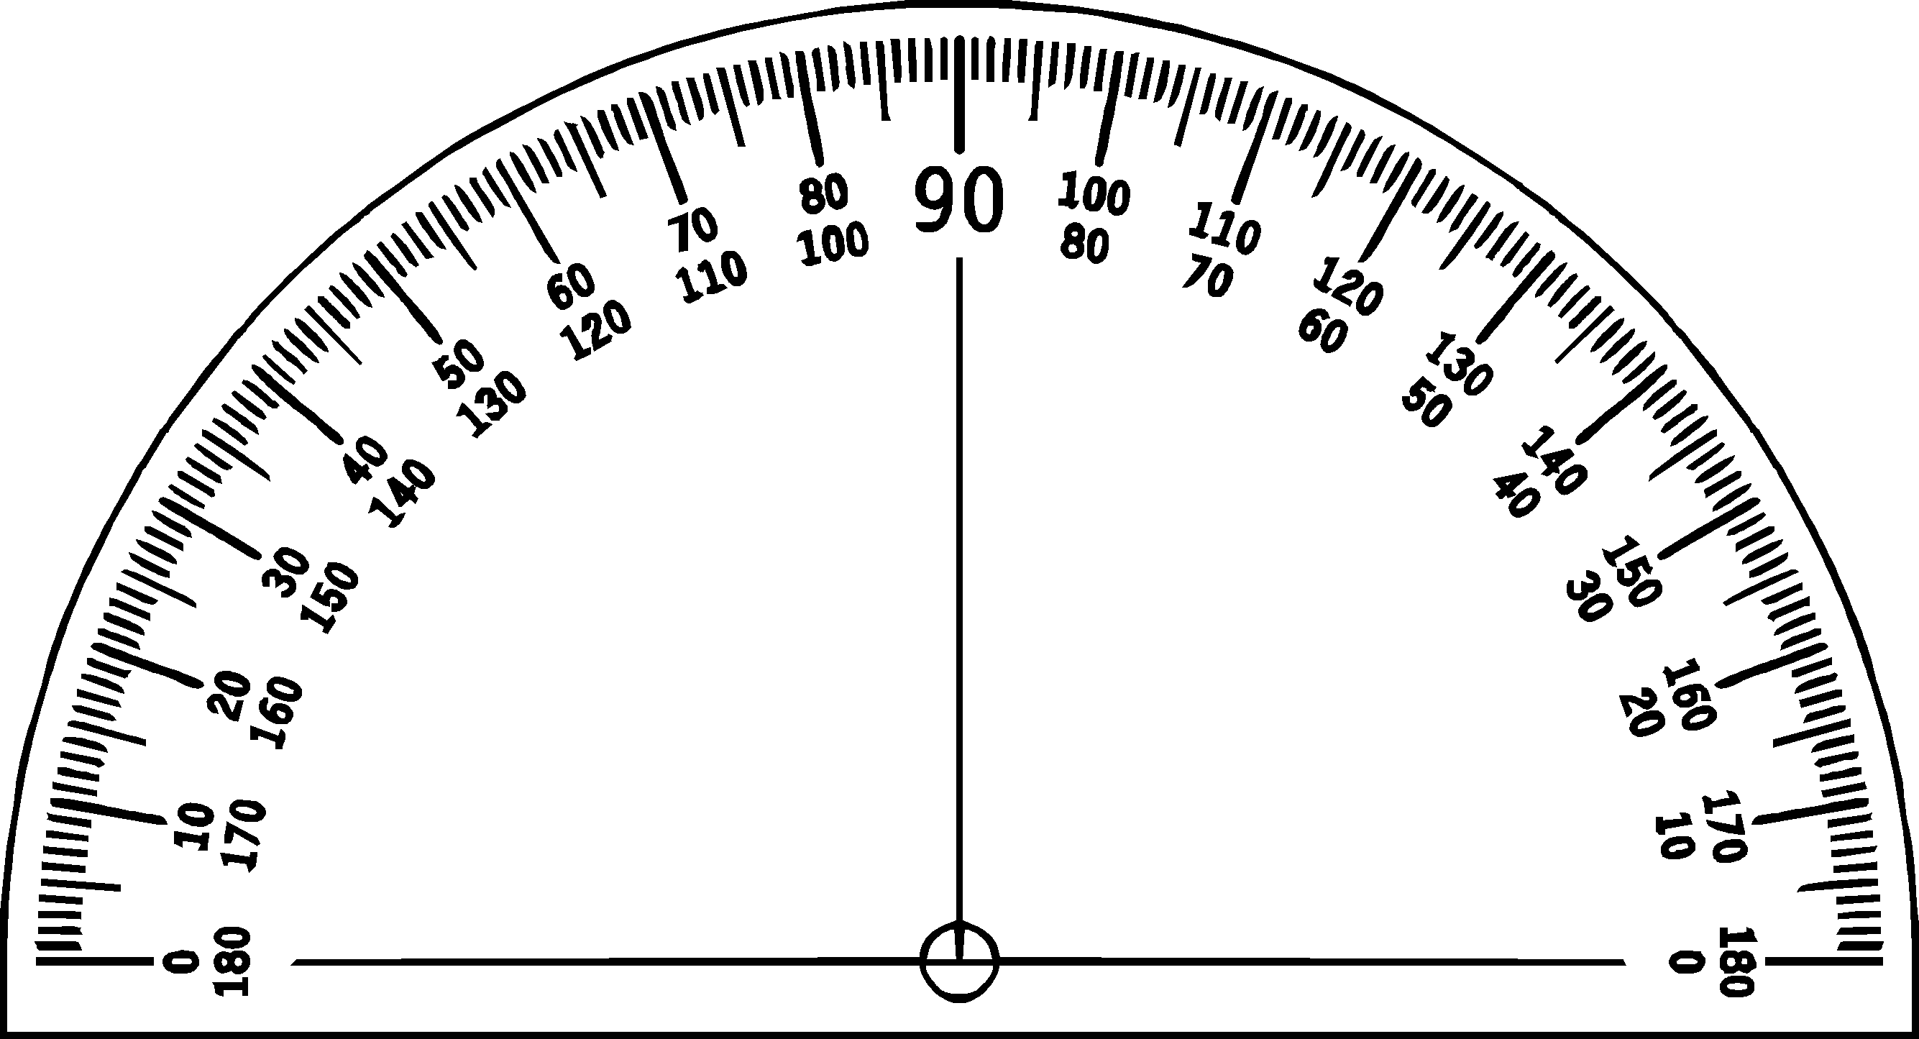

Types of Angles | Definition | Picture
Acute | An angle measuring less than 90º
Obtuse | An angle measuring more than 90º
Right | An angle measuring exactly 90º
Straight | An angle measuring exactly 180º

1) | 2)
3) | 4)
Pause the video and try these on your own!
Then press play and check your answers with a color pen

Measure each angle to the nearest degree. Then name the angle.
1) | 2)
3) | 4)
5) | 6)

