 | Problem 1 | Problem 2 | Gridded Response
Monday | What is the value of y?  y  32 | Danny ran 4 miles in 45 minutes. Hannah ran and her distance is represented by the equation d = 7t (d=distance in miles, t = time in hours). What is the difference between unit rates? | Problem 1  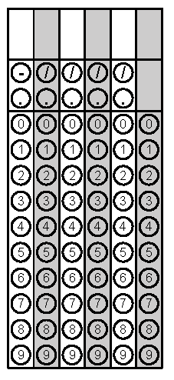
Tuesday | Will three sides of any length create a triangle? Explain how you know which will work.  Possibilities to examine are:  - 13 cm, 5 cm, and 6 cm  - 3 cm, 3cm, and 3 cm  - 2 cm, 7 cm, 6 cm | Find the measure of x.  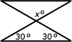 | Problem 2
Wednesday | Harry measured two angles in a triangle with a protractor. The first angle measured 68°, and the second measured 80°. What is the measure of the third angle? | Two angles in a triangle measure 102° and 54°. What is the measure of the third angle? | Problem 1
Thursday | In an isosceles triangle, the base angles are 2x + 2 and the vertex angle is 4x + 8. Find the measure of each angle. | Solve for the measure of angle S. | Problem 2
Friday | A neighborhood group has $28,000 to spend on improvements to a park. They spend $7,600 on playground equipment and $115 on each tree. Write an inequality and solve for the maximum number of trees the group can buy. | Write and solve an equation to find x.  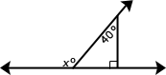 | Problem 2
Questions adapted from Score21 and SchoolNet

