 | Problem 1 | Problem 2 | Gridded Response
Monday | One angle has a measurement of 3x and another has a measurement of 12x. If the two angles are supplementary, what’s the measure of the larger angle? | ∠WXZ and ∠ZXY are complementary angles. ∠WXZ is four times larger than ∠ZXY. What is the measure of ∠WXZ? | Problem 1  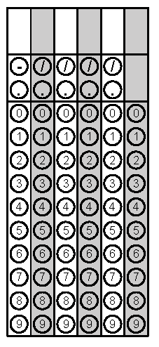
Tuesday | Audrey went to the mall.  - She spent half of her money on a shirt.  - She spent $5.35 on lunch.  - She bought a pair of shoes for $21.39.  - She has $3.26 left.  How much money did Audrey take to the mall? | The larger of two complementary angles is 10 degrees more than the smaller angle. What is the degree measure of the larger angle? | Problem 2
Wednesday | If angle 1 is 150 degrees, find the measure of all the other angles and give your reasoning.  1 | Two angles of a triangle measure 48° and 62°. What is the measure of the third angle in the triangle? | Problem 2
Thursday | Find the measure of x.  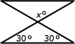 | Which set of angle measures would not be the interior angles of a triangle?  A 12°, 38°, 120°  B 22°, 48°, 110°  C 30°, 60°, 90°  D 40°, 60°, 80° | Problem 1
Friday | Jason purchased 10 shirts for the members of a school club. Each shirt cost $4.99. Jason had a coupon for 20% off his total purchase. Sales tax was 7% after the discount. What was the total cost for the shirts? | Find the measure of angle a. | Problem 2
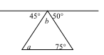
Monday Problem 2, Tuesday both problems, Wednesday problem 2, Thursday problem 2, and Friday problem 1 taken from SchoolNet.

