 | Problem 1 | Problem 2 | Gridded Response
Monday | Find the following absolute values and put the resulting integers in descending order. | Solve.  + - 4 when = 6 | Problem 2  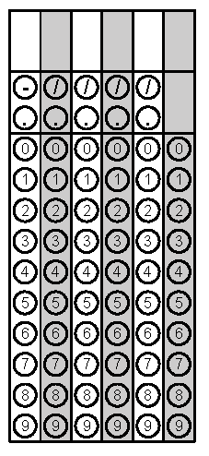
Tuesday | Simplify:  3x2 + 5x + 2(4x2 - 2) + 12 | Amy received $51 for selling 68 candy bars for a school fundraiser. At what rate was Amy selling each candy bar? | Problem 2
Wednesday | Joyce can type 360 words in 5 minutes. Robert can type 408 words in 6 minutes. Which one types at the fastest rate per minute? | Coach Jenson bought 15 shirts for $180 for the basketball team.  - What was the unit rate of the shirts?  - The unit rate for shorts was $1.50 less than the unit rate for shirts. Coach Jenson bought the same number of shorts as shirts to complete each uniform. What was the total cost of the uniforms for the team? | Problem 2B
Thursday | A person made 4 blankets. Each blanket used 180 inches of ribbon for the border. How many yards of ribbon did the person use for all four blankets? | Which sentence represents this equation?  4x - 2 = 12  A. Two less than four times a number is 12  B. Four times two less than a number is 12.  C. Four times a number is two less than 12.  D. Four times a number less than two is 12. | Problem 1
Friday | The school cafeteria makes pudding every Wednesday. Each box of pudding mix uses 3 cups of milk. How many quarts of milk will be used to make 80 boxes of pudding mix? | Solve: 2x + 6 = 32 | Problem 2

