 | Problem 1 | Problem 2 | Gridded Response
Monday | Find the value of each situation:  a) $\left|-10\right|$  b) $-\left|-10\right|$ | Distribute:  5(3x – 2) | Problem 1B  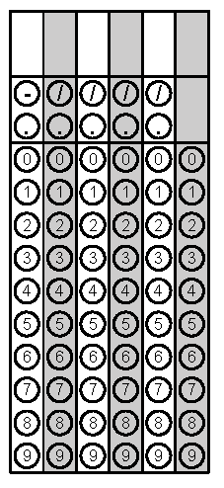
Tuesday | Write an equivalent expression for:  3(x + 5) – 2 | A woman is ordering pizza for a party. She can get 3 large pizzas for $26. At this rate, what will 12 large pizzas cost? | Problem 2
Wednesday | Subtract.  $3\frac{1}{4}- 1\frac{5}{6}$ | Stacy is having a pool party and wants to make sure she has the same number of hamburgers and hamburger buns. If hamburger buns come in packages of 6 and hamburgers come in packages of 4, how many packages of each should she buy to feed at least 18 guests 2 hamburgers each? | Problem 1
Thursday | Model (-4) two different ways. | Morgan has $4 and she needs to pay a friend $12. How much more money does Morgan need to be able to pay her friend? | Problem 2
Friday | Solve.  (-2) + 5 | Suzanne says the two expressions 2(3a – 2) + 4a and 10a – 2 are equivalent? Is she correct? Explain why or why not? | Problem 1

