 | Problem 1 | Problem 2 | Gridded Response
Monday | Divide 243 by 3. | When you think of the word ‘mathematics’ what does it make you think of? | Problem 1  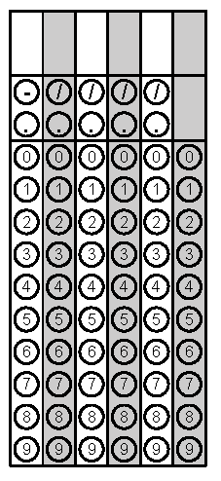
Tuesday | Simplify the Expression:  3x² + 2x – x + 5 | Java To Go wants to make sure the number of bags of coffee that show in the front of their shelves match. If their top shelf holds 16 bags, second shelf holds 32 bags, and bottom shelf holds 64 bags, how many bags should the employees make visible in the front row? | Problem 2
Wednesday | Solve.  $3\frac{1}{2}+ 6 \frac{6}{7}$ = | What is the order of operations?  What does it mean to combine like terms? | Problem 1
Thursday | Serg needs 4 pounds of chicken for his recipe. If three pounds cost $11.49, how much will 4 pounds cost him? | Write an expression for the following situation:  In the first quarter of a football game, Ben gained 12 yards, gained another 4 yards, lost 3 yards, gained 5 yards, and then lost 11 yards. | Problem 1
Friday | Place the following numbers in ascending order and then grid in the greatest value.  $$\frac{20}{7} 3.1 2\frac{3}{4}$$ | Marci thinks that -1000 is a lot, Tre says that it is not a lot. What do you think and why? | Problem 1

