Name ____________________________

Math 8: Powers of Powers
Directions: Fill in the blanks below as you watch the video.
Write in expanded notation:

Now write back in exponential notation:

Power to a Power Property
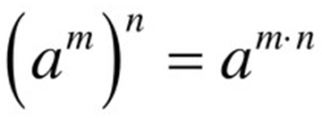
Simplify.
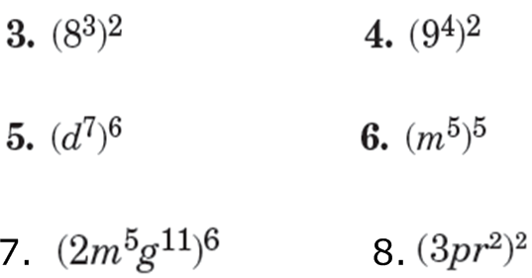

You Try! Simplify.
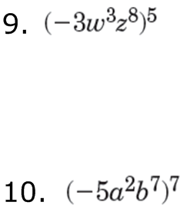

Simplify.

You Try! Simplify.

Be careful! Make sure you know the difference …
