**M7: Unit 8 - Data Study Guide**

**Multiple Choice**

*Identify the choice that best completes the statement or answers the question.*

**1.** Use the two box-and-whisker plots to determine which statement is true.



|  |  |  |  |
| --- | --- | --- | --- |
| **A)** | They have the same median. | **C)** | The upper quartiles are equal. |
| **B)** | They have the same range. | **D)** | The lower quartiles are equal. |

**2.** Which statement is NOT true about this box plot that describes the number of minutes students spend studying for each class?

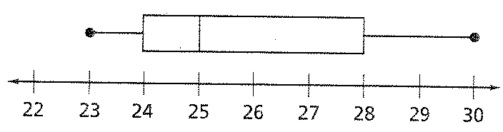

|  |  |
| --- | --- |
| **A)** | 25% of the data falls within 23 minutes and 24 minutes |
| **B)** | 25% of the data is above 28 minutes |
| **C)** | 75% of the data is below 25 minutes |
| **D)** | 50% of the data falls within 25 minutes and 30 minutes |

**Short Answer**

**3.** Consider the data set below. Create a box plot of the data.

20, 17, 14, 16, 4, 21, 1

**4.** Describe the data in the box-and-whisker plot.



**5.** Steve and Julia are running for 7th grade class president. Steve is on the baseball team and Julia is in art club. Give examples of bad sampling methods.

**6.** Out of 960 discs tested, 12 are defective. Estimate the number of defective discs in a batch of 40,000.

**7.** You want to find out the favorite subjects of students at your school. Describe a way to gather a good sample.

**8.** The table shows the quantity or licorice sold versus the quantity of snow caps sold at the movie theater for the days Wednesday through Sunday.

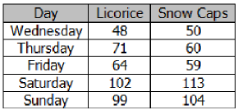

What is the difference between the mean of the number of licorice sold and the mean number of boxes of snow caps sold?

**9.** Victoria compares her math test scores to her science test scores. By how many points is Victoria’s median science score *greater* than her median math score?

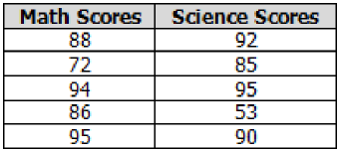

**10.** Kelly took a survey of two different sets of 100 students to see what their favorite pizza toppings are and displayed the results in the table below.

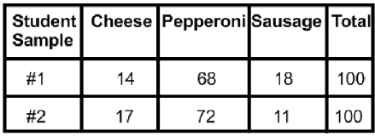

What inferences can be drawn based on the results?

**11.** Edward is part of a bird watching club and wants to keep track of robins. To do so, he puts tags on 50 robins and releases them. Later, he catches 90 robins; 15 were tagged. What is the best estimate for the robin’s population?

**12.** What are considered Measures of Spread (Variability)?

What are considered Measures of Center?

**13.** Mrs. Haywood made dot plots of her 2 math classes’ recent math tests. What is the mean of 1st period’s data?

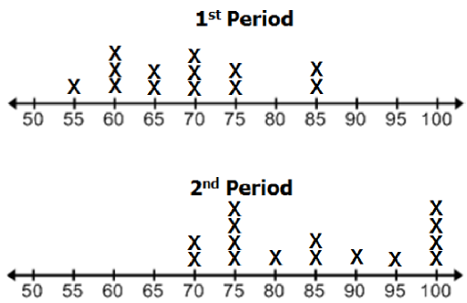

**14.** The line plot below shows the number of text messages sent..

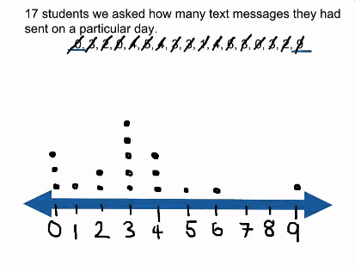

How many students sent texts? What is the median? What is the range?

**15.** The two data set below depict random samples on time spent on homework in one week.

**Science:** 1, 3, 4, 2, 3, 4, 4, 3, 2, 2, 0

**Math**: 2, 2, 1, 3, 5, 4, 5, 3, 4, 5, 4

Based on the times above, which measure of center will provide the most accurate estimation of hours for each data set?

**16.** Find the Mean Absolute Deviation of the data set below. Round to the nearest tenth, if necessary.

|  |  |  |  |  |
| --- | --- | --- | --- | --- |
| 20.2 | 17.5 | 24.2 | 23.1 | 16.2 |
| 25.2 | 18.9 | 24.7 | 18.2 | 13.8 |

**17.** Complete the statements:

As the MAD value increases, the variability __________________.

As the MAD value decreases, the variability __________________.

**18.** Draw a picture of each of the following: skew right, skew left, and mound shape (bell curve).

**19.** Gia compared the mean age of the members of a local travel club and book club. She created two dot plots as shown below.

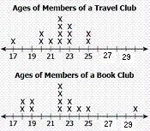

Find the mean and median of each data set. List the Ages of Members of a Travel Club.

**20.** A worker takes a random sample of 150 bolts and finds that 9 of them are either too long or too short, thus making them unusable. Estimate the number of unusable bolts in a production of 18,000 bolts.

**21.** Find the range and the first and third quartiles for the data set.

66, 72, 73, 15, 65, 45, 77

**22.** Give the five-number summary for the given box plot.

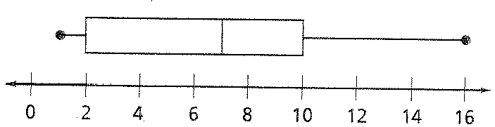

**23.** Ms. Morse is comparing the test scores of her 1st period to scores of her 3rd period. The Mean Absolute Deiviation of 1st period is 1.7, and the Mean Absolute Deiviation of 3rd period is 2.1. What conclusion can Ms. Morse draw about the two classes?

**24.** The heights of five rose plants, in inches, selected at random from a park with 50 rose plants are shown below:

**78, 118, 157, 39, 98**

Which is a *reasonable prediction* of the mean height of all the rose plants in the park?

**M7: Unit 8 - Data Study Guide**

**Answer Section**

**MULTIPLE CHOICE**

**1.** A

**2.** C

**SHORT ANSWER**

**3.** 

**4.** The values range from 46 to 89. At least half of the data are within 12.5 points of the median, 64.

**5.** Only asking the art club members, only asking members of the baseball team, asking 6th grades, asking 8th graders, asking the parents, etc.

**6.** about 500 discs

**7.** Ask every 10th person you see in the hallway as you walk around the school. (Everyone has an equal chance of being chosen.

**8.** 0.4 (Licorice: 76.8, Snow Caps: 77.2)

**9.** 2 (Math: 88, Science: 90)

**10.** Perpperoni is the most liked pizza (about 70%). Cheese and Sausage are liked about the same.

**11.** about 300 robins

**12.** Spread: Range, IQR, and MAD

Centes: Mean and Median

**13.** 68.846; 895/13

**14.** There are 17 students in the class.

Median: 3

Range: 9-0 = 9

**15.** Mean because all of the data values are close together. You would use the median if the data included an outlier because the outlier skews the data. You never use mode, range, IQR, or MAD to estimate a data set.

**16.** 3.28 = 3.3

**17.** As the MAD value increases, the variability **increases.**

As the MAD value decreases, the variability **decreases.**

**18.** Skew Right Skew Left Mound Shape

x x x x

x x x x x x x x x

x x x x x x x x x x x x x x

x x x x x x x x x x x x x x x x x x x x x x x x x

**19.** Mean of Travel: 21.92, Mean of Book: 22 - These are about the same

Median of Travel: 22, Median of Book: 22 - These are exactly the same

Name the Ages of Members of a Travel Club: 17, 20, 20, 21, 22, 22, 22, 22, 23, 23, 23, 25, 25

**20.** 1,080 bolts

**21.** Range = 62

First quartile = 45

Third quartile = 73

**22.** 1, 2, 7, 10, 16

**23.** Althuogh the MADs are fairly close, there is more variation in 3rd period’s scores.

**24.** 98 inches