Name ____________________________

Math 8: Dividing with Exponents
Directions: Fill in the blanks below as you watch the video.
Write in expanded notation:
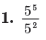 | 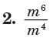

Now write back in exponential notation:

___________ ____________

Quotient of Powers Property
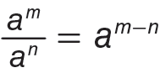
Simplify.
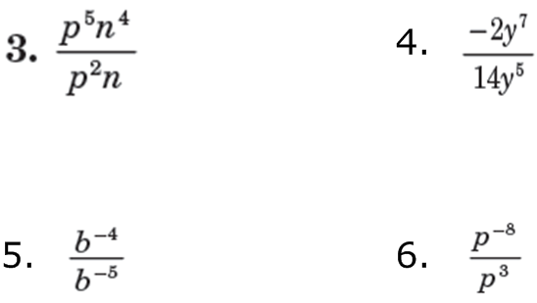
You Try! Simplify.

Simplify.
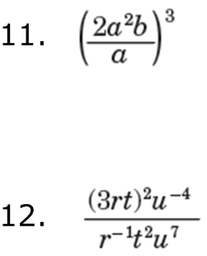

You Try! Simplify.
